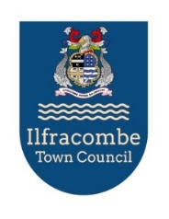

ILFRACOMBE TOWN COUNCIL
Mayor: Mark Fay Proper Officer: Laura Donnovan

THE ILFRACOMBE CENTRE, HIGH STREET, ILFRACOMBE, DEVON, EX34 9QB, 01271 855300

January 2026

Re: CHEYNE BEACH CAR PARK 2026/27 SEASON

Please find the enclosed form, which must be completed in order to purchase a permit(s) for the year 2026/27. The new permit(s) will be valid from 15th March 2026 to 31 October 2026 in Cheyne Beach Car Park only and from 01 November 2026 to 14 March 2027 in Ropery Road Car Park. Please note that Ropery Road car park can only be used during this period and not at any other time, even in the event of bad weather. You are still able to utilise Cheyne Beach Car Park between November and March BUT as advised below it is your responsibility to check conditions.

As you may be aware, Cheyne Beach Car Park is liable to flooding. It is your responsibility to check tides together with weather conditions and move your vehicle if you feel it is necessary to do so. We do on occasions receive bad weather/flood warnings and may contact permit-holders as a matter of courtesy only. Permit holders must park in Cheyne Beach Car Park at their own risk.

Parking enforcement will be in operation and any vehicle not displaying a valid permit will be subject to a Parking Charge Notice. The management and enforcement operation of PCNs will be carried out by North Devon Council and all details with reference to the issue of a PCN will be dealt with wholly by North Devon Council. Please be reminded that vehicles must be parked wholly within a bay in all car parks.

There may be occasions when works need to be carried out on or around the car park by either the Environment Agency or South West Water so you may be contacted with regard to alternative parking arrangements.

You are able to list 2 registration numbers on 1 permit. However, only 1 permit will be issued and only 1 listed vehicle (registration number) can be parked at any one time.

In order for us to be able to contact you in the event of works or wave barrier erection, please ensure that you provide your current e-mail address and an up-to-date contact telephone number on the form.

The form is to be returned ASAP to the council office and due to demand, permits will be on a 1st come basis.

Only 1 permit will be issued to any named individual in the first phase due to the large waiting list and you will be made aware of your successful application on the issuing of an invoice, Payable within 14days of invoice. Once this has been paid, new permits will be available for collection from the Ilfracombe Centre, they will not be posted or hand delivered.
During the 2nd phase we will revisit those who have requested more than one permit and inform them of their success via invoice only if they have paid the original permit invoice.

Any abusive language or actions will not be tolerated and could lead to the removal of the permit from the holder.

The cost of the permit is £408.00 (including VAT) for the year 2026/27 (15/03/26 – 14/03/27 inclusive).
You have one free change of permit, any future changes will be charged at £30 (including VAT) to cover administration fees. The purpose of this car park is for those working or living in the harbour area and is not designed to accommodate visitors to the town.

If you wish to cancel a permit, monies received will be refunded pro rata from the next full calendar month. We will require notice of cancellation in writing plus cancelled permits to be returned.

Yours sincerely,

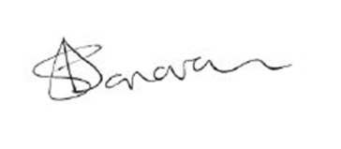

Ilfracombe Town Council

