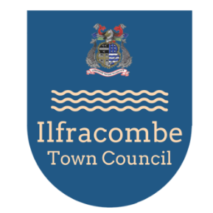

CHEYNE BEACH PERMIT FORM 2026/27

I WISH TO PURCHASE A PERMIT (S) FOR THE YEAR 2026/27 (15 March 2026 to 14 March 2027)
At a price of £408 (for each permit purchased) to be invoiced if you are successful in obtaining a permit.

Name:
Occupation:
Address:
Contact number:
Email:
Name to be shown on permit:
Vehicle registration number:
Additional registration number:
I am interested in purchasing more than 1 permit | Yes No Number:

I am aware that the car park is liable to flooding and that my vehicle is parked at my own risk. I have read the accompanying letter indicating the permit validity with regard to parking restrictions

Signed:

Date:

This form MUST be returned to:

The Parking Team, Ilfracombe Town Council, 44 High Street, ILFRACOMBE, EX34 9QB

Or via Email: theilfracombecentre@northdevon.gov.uk please add PERMIT in the subject

